Rahil_Shah_SQL_2_2

Q-1 Find the vendors that have no orders

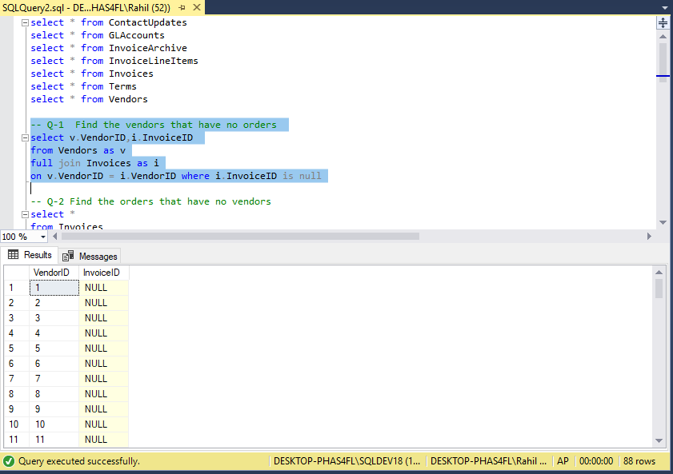

Q-2 Find the orders that have no vendors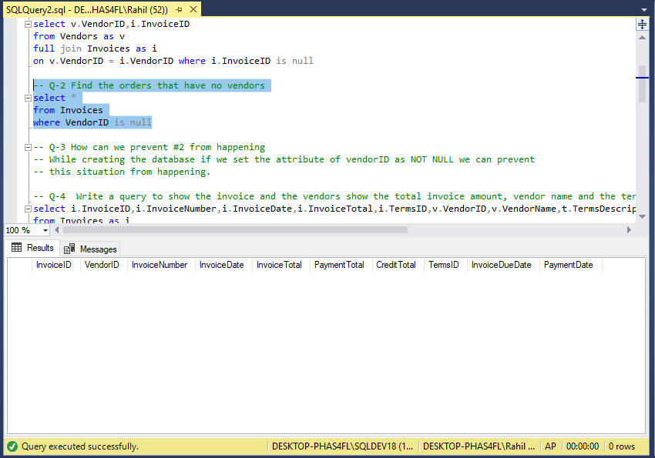

Q-3 How can we prevent #2 from happening

While creating the database if we set the attribute of vendorID as NOT NULL we can prevent this situation from happening.

Q-4 Write a query to show the invoice and the vendors show the total invoice amount, vendor name and the terms of the invoice (not just the term id)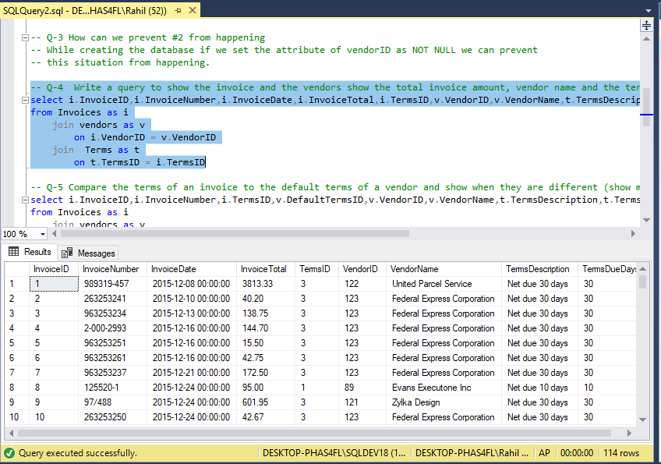

Q-5 Compare the terms of an invoice to the default terms of a vendor and show when they are different (show more than the term id)

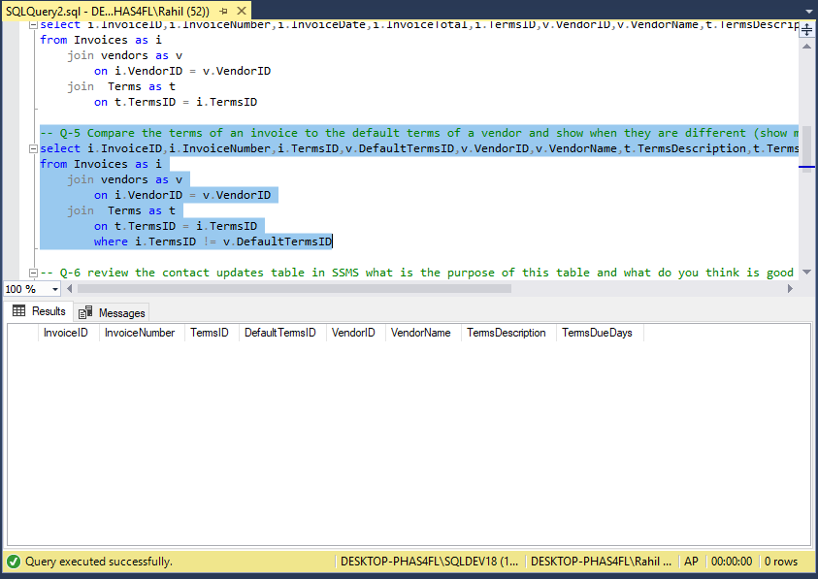

Q-6 review the contact updates table in SSMS what is the purpose of this table and what do you think is good or bad about the design choices

I think that using the GLcontactsupdate is a good approach to update the contact names of the table without touching the actual table.

Q-7 Find all the vendors who have a contact with a vowel 'aeiou' in the second character of thier first name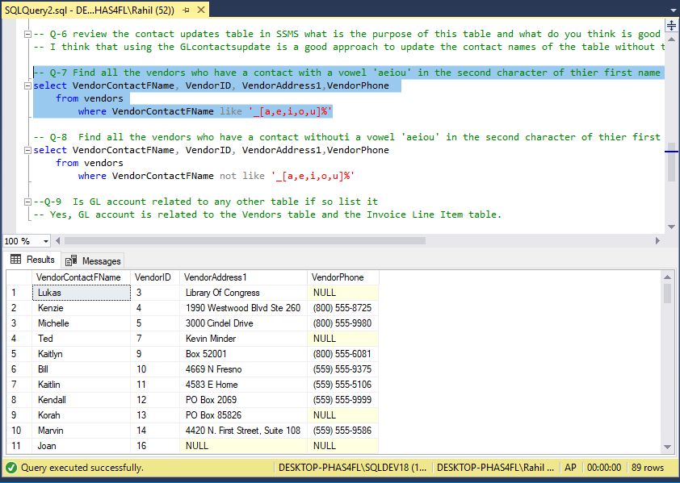

Q-8 Find all the vendors who have a contact withouti a vowel 'aeiou' in the second character of thier first name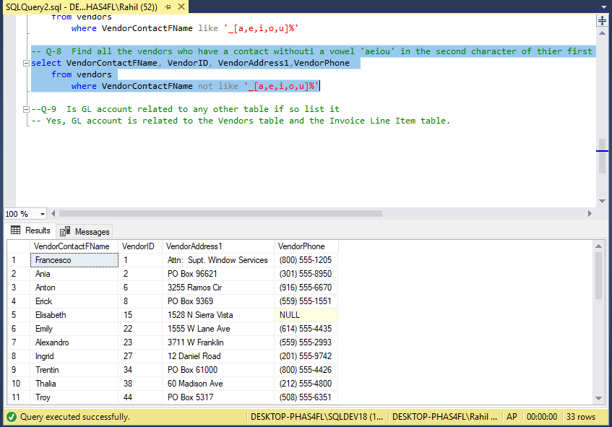

Q-9 Is GL account related to any other table if so list it

Yes, GL account is related to the Vendors table and the Invoice Line Item table.